DIRECT DEPOSIT AUTHORIZATION

Employee Name: ______________________________________SSN: ____________________

Address: _____________________________________________________________________

City, State, Zip: _______________________________________________________________

Telephone: _______________________________ Email: ______________________________

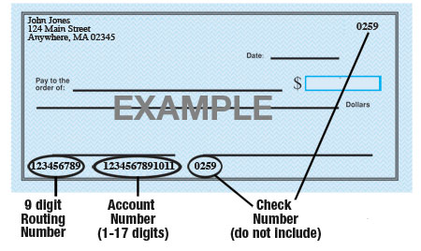

Name of Bank: ____________________________________________________________

Account #: ____________________________________________________________

9-Digit Routing #: ____________________________________________________________

Amount: ☐ $ ____________ ☐ ___________%  or ☐ Entire Paycheck

Type of Account: ☐  Checking ☐  Savings (Check One)

Attach a voided check for each bank account to which funds should be deposited (if necessary)

The employer processes payroll on a semi-monthly basis, with pay periods ending on the 15th and the last day of each month. Paychecks will be issued on the 5th day following each pay period.

I hereby authorize the employer to directly deposit my pay into the account listed above. This authorization will remain in effect until I provide a written notice to modify or cancel it.

Employee’s Signature: ____________________________________ Date: _________________

